linux lab
tarun prabhath
17mis1078
1)sl-funny train runs in terminal:
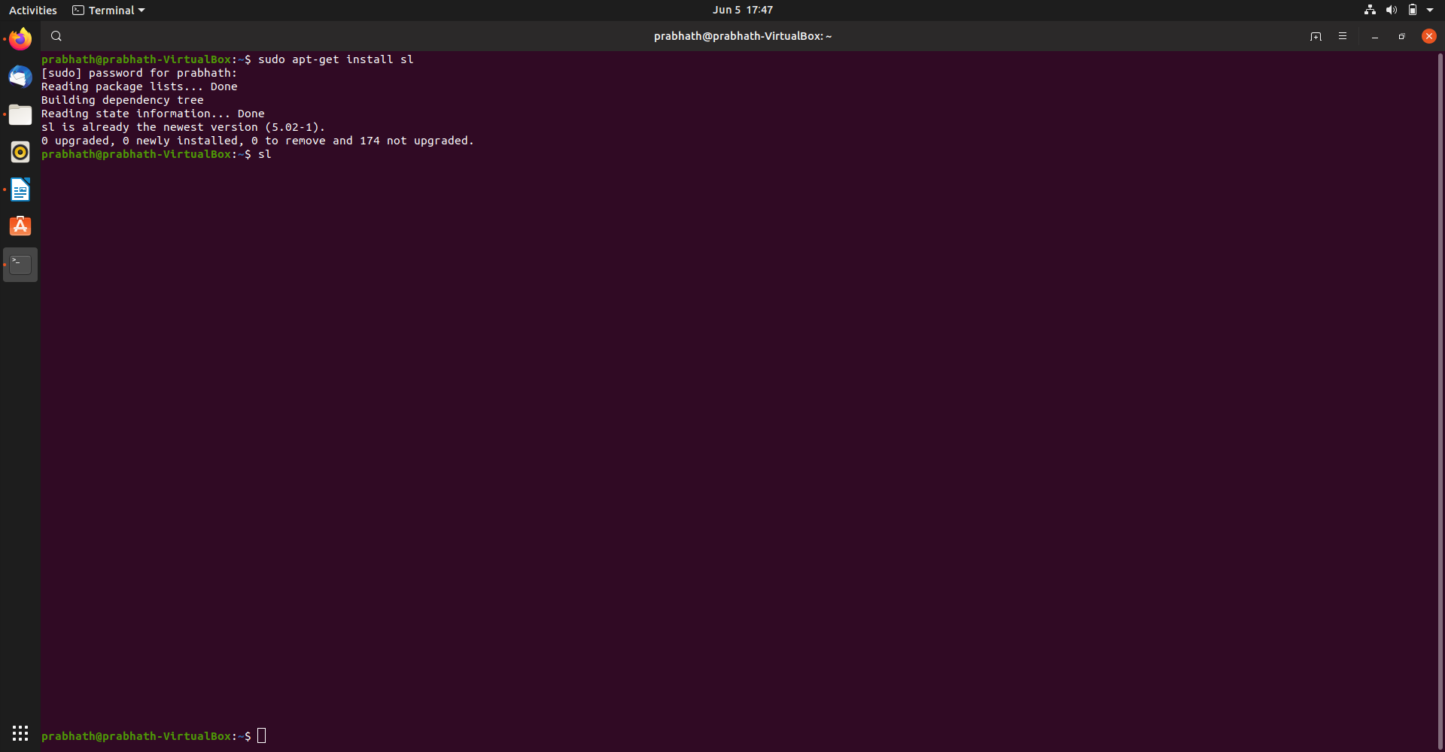

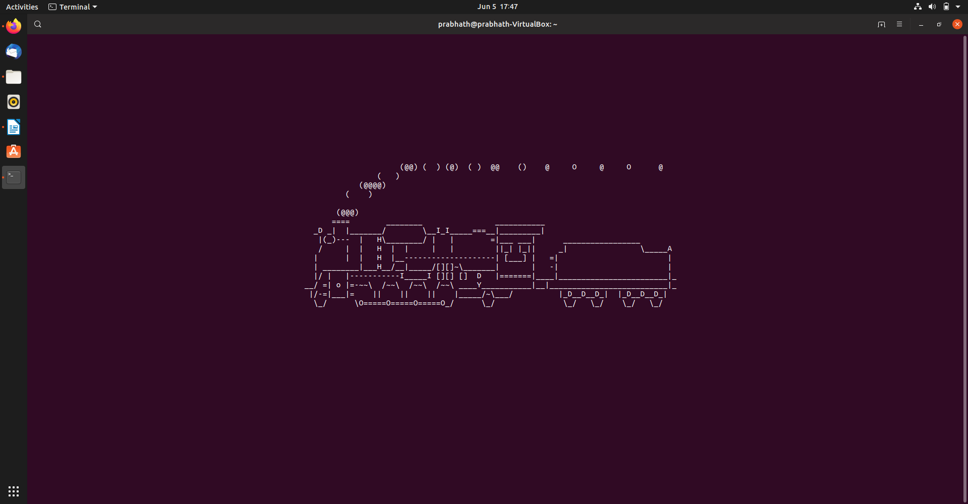

2)Rev Command in Linux: Usage: Rev [text] or[filename] rev -h ---Help rev -V ---Version Number

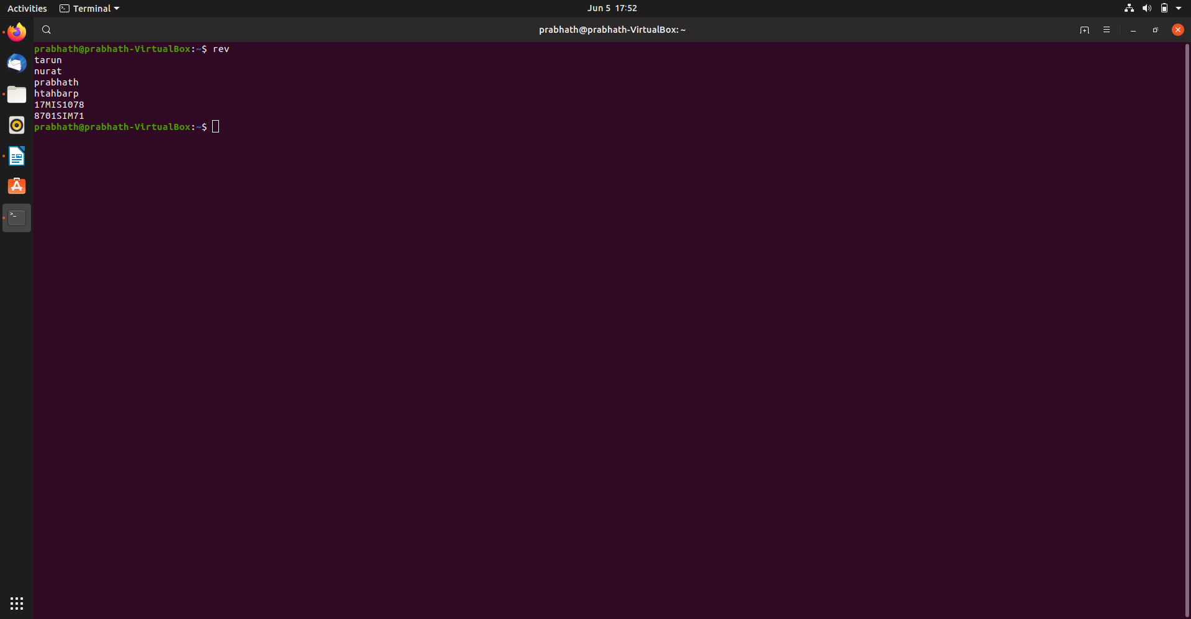
3)Factor:The factor command in Linux is used to print the prime factors of the given numbers.

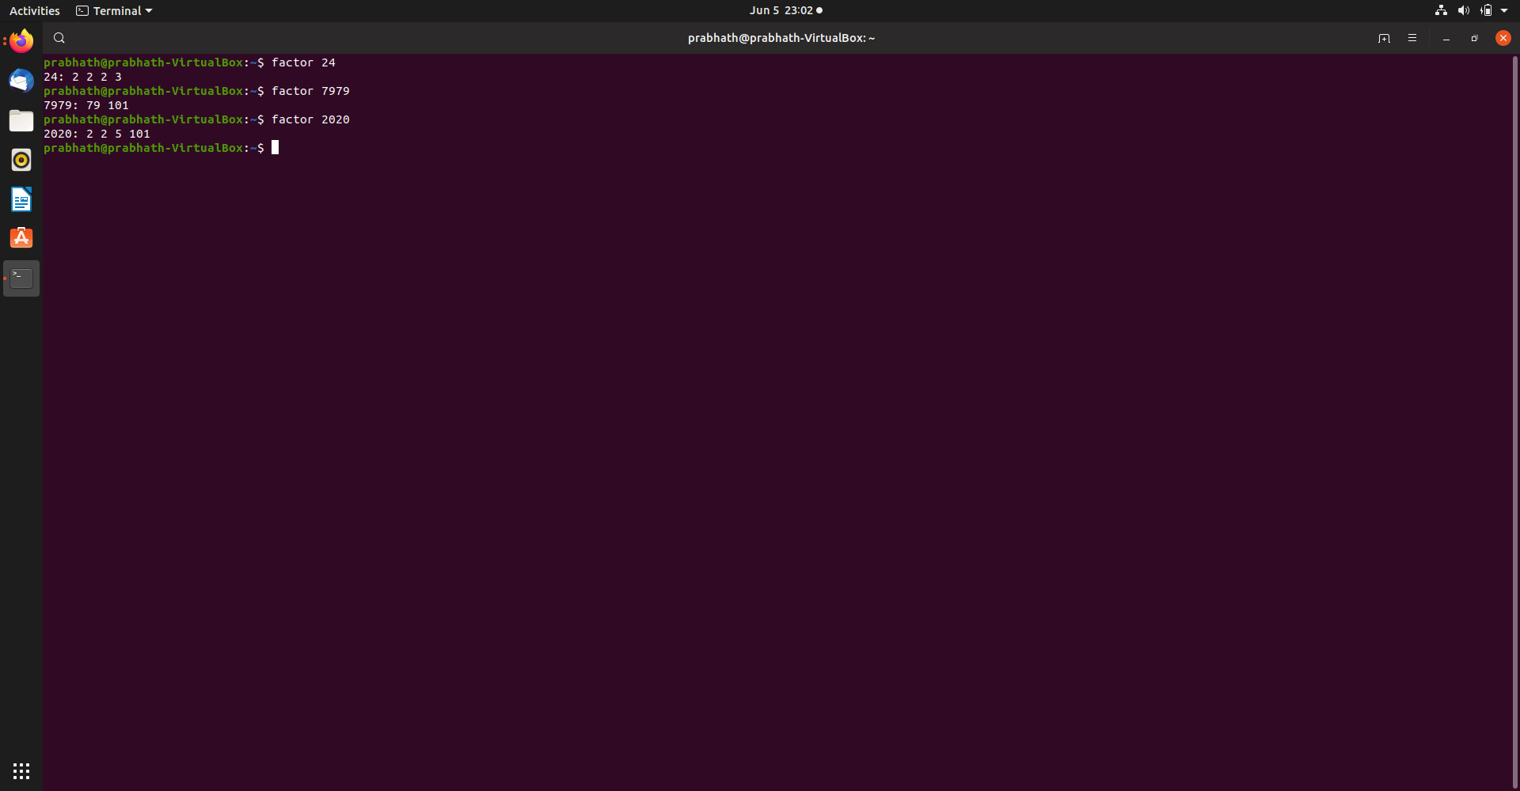
4)yes: yes command in linux is used to print a continuous output stream of given STRING. If STRING is not mentioned then it prints ‘y’
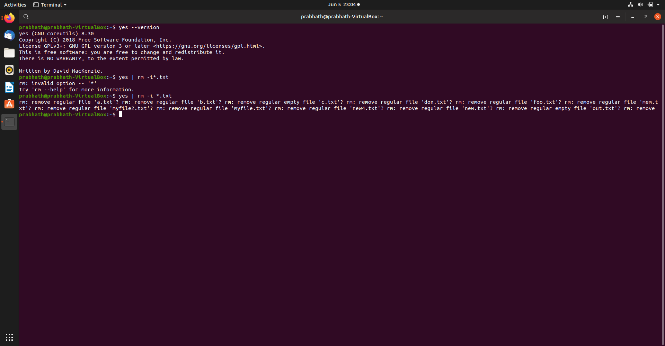
5)Instructions: crontab -e --- to install the shell script for automation Health monitor used in the scenario: Top---process info free---memory usage in the system netstat---network info and socket connected info vmstat—virtual mem and cache info

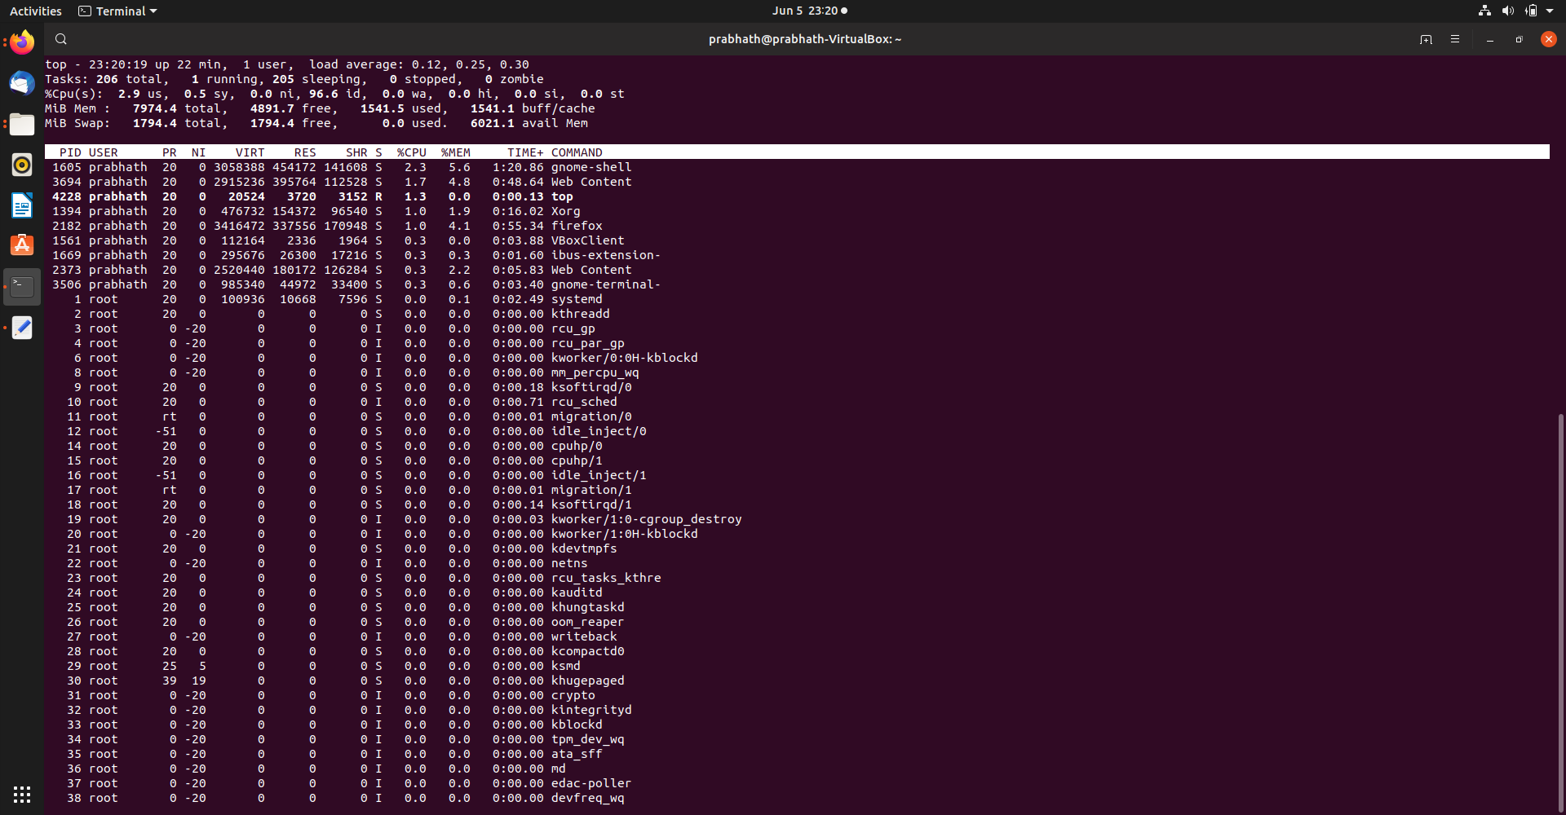
code:
vmstat 1200 > vmstat1.data
filename= "/home/prabhath/vmstat1.data"
tail -f $filename |
while read $line do
if [ (cat vmstat1.data | grep "swap")>0 ]
then
echo "some rogue process has consumed massive amounts of memory"> swap.txt
fi
if [ (cat vmstat1.data | grep "r")>1 ]
then
echo "some process are waiting to execute"> runqueue.txt
fi
if [ (cat vmstat1.data | grep "cpu")>1000 ]
then
echo "cpu usage is more"> cpu.txt
fi
End

